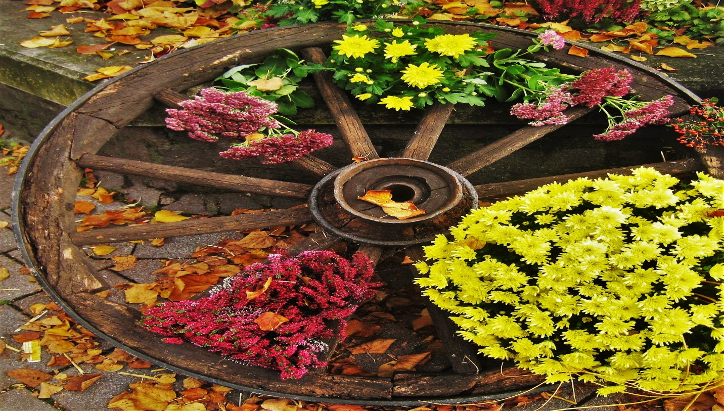

TOWN OF BEAN STATION
28th Annual Harvest Festival
Saturday October 18, 2025, 9:00 a.m. - 5:00 p.m.
Vendor Set up Friday October 17, 2025, noon - 6:00
Saturday October 18, 2025, 7:00 a.m. - 8:30 a.m.
VENDOR BOOTH APPLICATION FORM
Please read all rules and regulations carefully
before mailing.
Subject to approval of this application, I understand that I will be provided a 10’x10’booth space. Vendor must supply their own tables, chairs, and canopy.

COMPANY/ORGANIZATION:__________________________________________________
DESCRIPTION OF YOUR PRODUCT:

CONTACT NAME:____________________________________________________________
MAILING ADDRESS:__________________________________________________________
CITY:___________________________ STATE:___________ ZIP:____________
PHONE:_______________________ EMAIL:_______________________________

Please check all appropriate boxes:
BOOTH COSTS BY NUMBER OF SPACES: (Booth Fees are for each 10’x10’ booth) Example: one space is $35.00 two spaces will be $60.00
Non-Profit Organization Only: Must provide a copy of 501c3 with application
___________________Non-Profit __________________Additional non-profit $35.00
___________________Standard booth Craft & Commercial $35.00
___________________Electrical Booth $50.00 (spaces limited)
___________________Authors No Charge (Inside Courtroom)
___________________Food $35.00 per space non-electrical; $50.00 per space with electrical. Food vendors are required to bring a tarp to capture all cooking grease. Each vendor provides all extension cords, tables, etc.
Please specify type of booth: craft, food vendor, or commercial:_______________________________
How many booth spaces wanted:___________
Please initial each of the following:
_______________This is only an application. It will be first come first serve.
_______________You will be notified of your specific booth(s) location as we approach the festival date.
_______________MONEY IS NON-REFUNDABLE
_____________ You must be self-contained. No power, water, tent, or chairs will be provided.
________________Tent must be secured.
________________No motor vehicle parking in festival area after set up. Vendor parking will be
announced upon set up.
________________No early tear down or removable of booth.
All participants must fill out and sign an application form.

HOLD HARMLESS AGREEMENT:
I, The vendor, hereby agree to indemnify, defend, and hold the Bean Station Harvest Festival Committee and all of their employees, agents, representatives, and volunteers harmless from and against any and all claims, liabilities, losses, damages, costs, expenses (including attorney’s fees), judgments, and penalties arising out of (i) any third party claims concerning alleged defective products or merchandise manufactured, distributed, provided and/or sold by the Vendor, (ii) any act or omission to act of the Vendor, its employees, servants, and agents. I understand the Bean Station Harvest Festival reserves the right to remove any vendors that they deem inappropriate to the Bean Station Harves Festival. I acknowledge failure to comply with the standards of being “suitable for all ages” may result in my removal from the Bean Station Harvest Festival and jeopardize my participation in future Festivals. I understand that there are no refunds or rain checks due to inclement weather. In consideration of the 2024 Bean Station Harvest Festival’s acceptance of my application, I agree to accept all decisions of the Festival Committee as final. I agree to allow the Bean Station Harvest Festival use of enclosed promotional materials, as well as photographs and videotapes taken during the prior Harvest Festivals, for purposes of promoting the festival this year and in future years. I also agree to allow the Bean Station Harvest Festival to release my name to the public for promotion. I understand the Bean Station Harvest Festival does not carry insurance to cover my personal property, merchandise, product, or equipment and that I store and present my produce, merchandise, and equipment at my own risk.
I have read and agree to abide by the terms and conditions of this application. I understand and agree by signing any false statement will result in forfeiture of booth space and all fees.
Signature:________________________________________Dated:_______________

Make checks payable to the Bean Station Harvest Festival. For questions,
Email: parks@beanstation.org ; or Call Michelle Vaulton 423-736-1674 or
Town Hall 865-993-3177
Please return this form with your booth fee no later than October 1, 2025, to:
Bean Station Harvest Festival
785 Main Street
Bean Station, TN 37708

